AN AWARD WINNER INTERNATIONAL ORGANIZATION
PROMOTING EXCELLENCE IN DENTAL EDUCATION
Over 7000 Members Strong
A Must attend seminar for you and your staff
Presents
COSMETIC DENTISTRY
BY
DR. MARC GEISSBERGER

On June 13, 2027 (Sunday) 9:00 am till 4:00 pm
(CA Board 7 hrs. C.E. units)
at

Quiet Cannon 77 Bella Verde Dr, Montebello, CA 90640

(Please print in capital letters or attach your business card)

DR/RDH/RDA/DA Lic # a Circle one

Name

Address

Cell no _____________________________ E-Mail_______________________________________________
ARE YOU A PDS MEMBER: YES/ NO
COMPLIMENTARY BREAKFAST, LUNCH & PARKING INCLUDED
REGISTRATION FEE |  | ONE WEEK BEFORE
Dentists Non-members | $109.00 | $119.00
Members | $99.00 | $109.00
Hygienist/R.D.A. Non-members | $89.00 | $99.00
Members | $79.00 | $89.00
FOR REGISTRATION
BY PHONE 909-933-9076 OR Send Text Message to 909-638-2226
TO REGISTER ONLINE VISIT US ON www.pdsociety.com

Make check payable to
Dr. D.P. Singh Nagra
Chairman

Dr. R. Salwan
President
Punjabi Dental Society 124 EAST F STREET SUITE #8 ONTARIO, CA 91764

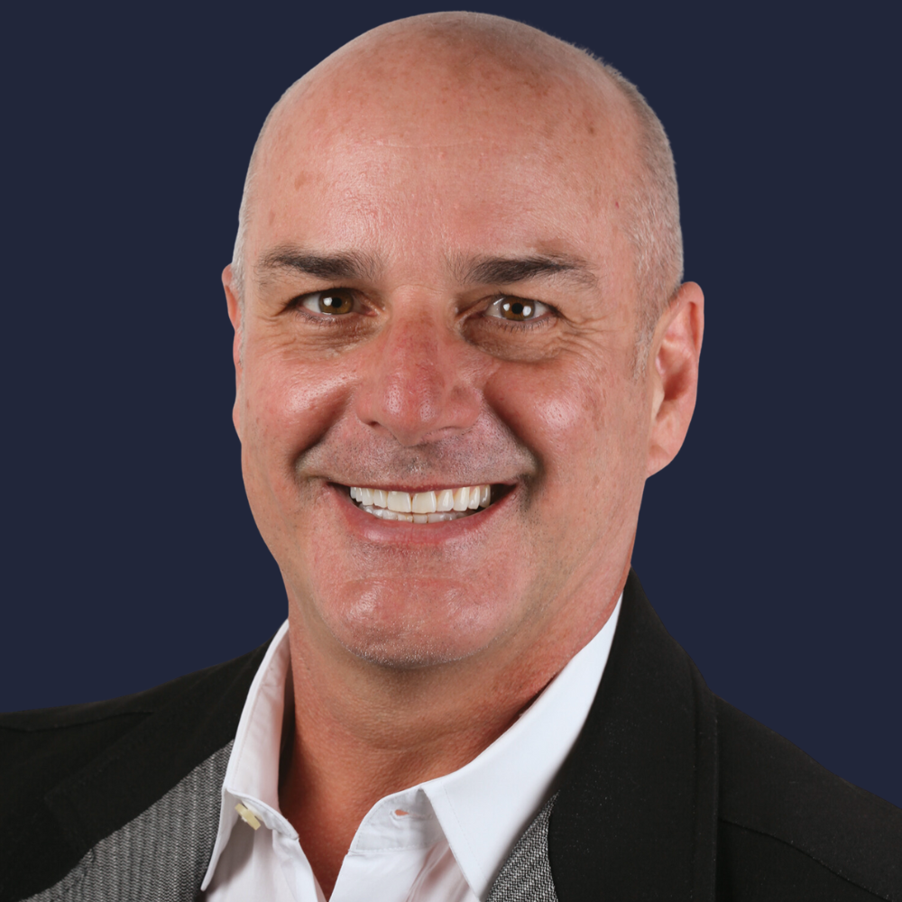

Course Date & Time:

Sunday, June 13, 2027

9:00 AM - 4:00 PM Pacific Time (US & Canada)

Duration: 7 Hours

Dr. Marc Geissberger
Dr. Marc Geissberger taught at University of the Pacific for 30 years and served as department chair of Integrated Reconstructive Dental Sciences for 15 years. He ran Pacific’s prestigious complex and esthetic rehabilitation program. He is a fellow of the American Dental Education Association’s leadership institute, researcher, as well as a published author in the areas of dental materials, contemporary fixed prosthodontics, and esthetic dentistry. He has lectured nationally and internationally in the areas of adhesive dentistry, cosmetic dentistry, photography, ceramic, fixed prosthodontics and treatment planning. Dr. Geissberger serves as a consultant for many dental materials companies and helps guide product development. During his 30 years in academia, he has maintained a private practice geared toward restorative dentistry with his brother and fellow Pacific alum Dr. Jeffrey Geissberger. He believes his continual involvement in providing patient care as well as a role in academia has given him a unique balance that allows him to blend the best of both worlds.
A member of the Catapult Group, Dr. Geissberger has been awarded fellowship in the International College of Dentists, American College of Dentists, and the Pierre Fauchard Academy. He has won several teaching awards and has presented over 450 lectures and hands-on workshops to colleagues in the United States, Canada, Australia, New Zealand, China, Peru, Denmark, and Taiwan. He has co-authored and published numerous scientific papers and a textbook entitled Esthetic Dentistry in Clinical Practice for Wiley-Blackwell which is currently available in 4 languages (English, Spanish, Polish and Turkish). Dr. Geissberger earned a master’s degree in educational psychology in 1994 and has been a Certified Personal Trainer (CPT) with the National Academy of Sports Medicine since 2008. He completed his Fitness Nutrition Specialty (FNS) training in 2011.
Dr. Geissberger’s goal is to provide educational experience for your group in a non-intimidating format that focuses on providing the clinician with the latest techniques and information that can be immediately incorporated into everyday practice. Presentations tend to be rich in information and Dr. Geissberger pledges to both entertain and educate simultaneously. All topics can be customized to the specific interests of the group, and many topics can be paired with a hands-on workshop.

Anterior Aesthetics as an Art Form, Treatment Planning for Aesthetic Dentistry…An Artist's Approach
Involving the whole team in Aesthetic Dentistry can be exciting and rewarding for all involved. A artistic approach to aesthetic dentistry is essential. This presentation will cover new techniques that have been developed to aid patients in visualizing potential aesthetic modifications of their dentition. We outline ways to involve the entire team in the treatment planning and delivery phases of aesthetics restorations.
During this program clinicians and staff members will:
- Learn the definition of esthetics in both dentistry and art
- Learn the scientific basis of esthetics in art and the world around us
- Develop a better understanding of the mathematical principles of esthetics compared to the esoteric esthetic concepts
- Understand the cultural differences in esthetic concepts
- Be able to evaluate the esthetic disposition of all patients
- Learn how to determine the esthetic values of each patient
- Learn to provide patients with a better understanding of aesthetic possibilities
- Learn how to create an office environment that promotes esthetics

THIS EVENT IS SPONSORED ARE PENDING


